Design and Development of an Online Food Ordering and Delivery
System for Don Macchiatos Using UML

Problem Statement
Many customers experience inconvenience when ordering food and beverages from coffee shops due to long waiting times, limited ordering methods, and lack of delivery options. Traditional ordering processes often require customers to physically visit the store, which can be time-consuming and inefficient.
Don Macchiatos customers may also encounter difficulties such as order miscommunication, delays, and lack of order tracking. Because of this, there is a need for an online system that allows customers to conveniently browse the menu, place orders, and track deliveries.
The proposed system aims to provide a reliable and user-friendly online ordering and delivery platform that improves efficiency for both customers and the coffee shop staff.

Project Objectives
- To develop an online platform where customers can easily order food and beverages from Don Macchiatos.
- To allow customers to browse the menu and customize their orders.
- To enable the coffee shop staff to manage incoming orders efficiently.
- To provide a delivery system that allows riders to deliver orders to customers.
- To allow administrators to monitor orders, users, and system activities.
- To evaluate the system's usability and efficiency based on user satisfaction and system performance.

Target Users
The system will be used by the following users:
- Customers – People who want to order food and drinks online.
- Coffee Shop Staff – Employees who prepare and manage customer orders.
- Delivery Riders – Individuals responsible for delivering orders to customers.
- System Administrator – Manages the system, users, and reports.
System Scope
Included in the System
- Customer registration and login
- Viewing Don Macchiatos menu
- Ordering food and beverages online
- Payment via Cash on Delivery (COD) or Manual Verification (Clarified to match "No External Gateway")
- Order Status Notifications (SMS/Email/In-App) (Added for Communication)
- Order preparation by staff
- Delivery process by riders
- Admin monitoring of orders and users
Excluded from the System
- Real-time GPS tracking integration
- External payment gateway integration (e.g., Credit Card, GCash API)
- Inventory management of raw materials
- Integration with third-party delivery services

Case Diagram
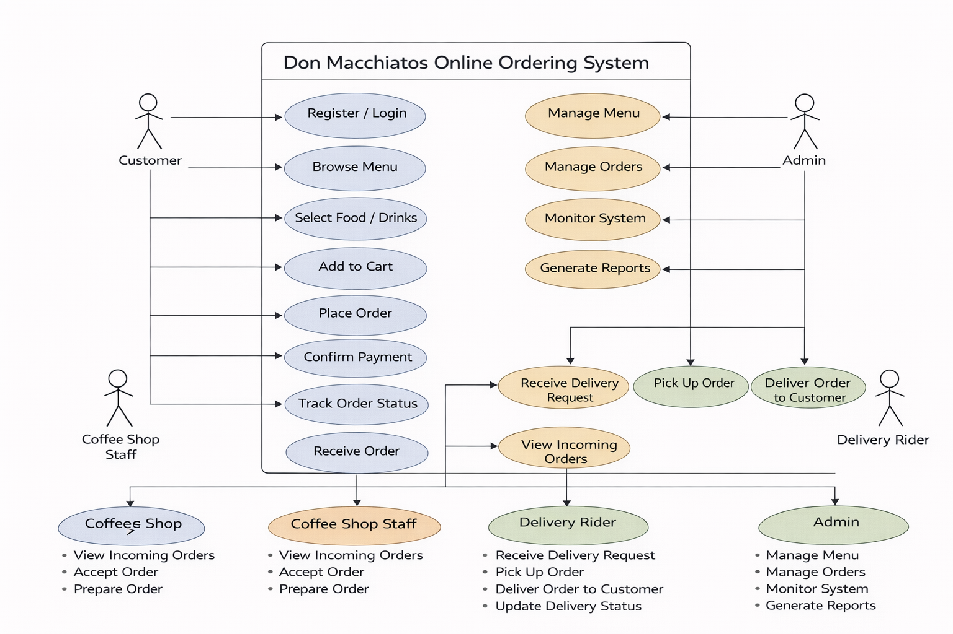
Use Case Diagram
A Use Case Diagram shows how different actors (users) interact with the system functions (use cases).
System Name:
Design and Development of an Online Food Ordering and Delivery System for Don Macchiatos Using UML

Actors in the Diagram

1. Customer - The customer interacts with the system to order food or drinks.
Customer actions:
- Register / Login
- Browse Menu
- Select Food / Drinks
- Add to Cart
- Place Order
- Confirm Payment
- Track Order Status

2. Coffee Shop Staff - The staff manages incoming orders and prepares them.
Staff actions:
- Receive Order
- View Incoming Orders
- Accept Order
- Prepare Order

3. Delivery Rider - The delivery rider is responsible for delivering the order to the customer.
Delivery rider actions:
- Receive Delivery Request
- Pick Up Order
- Deliver Order to Customer
- Update Delivery Status

4. Admin - The admin manages the system and monitors operations.
Admin actions:
- Manage Menu
- Manage Orders
- Monitor System
- Generate Reports

Simple Flow of the System
- The customer logs in or registers in the system.
- The customer browses the menu and selects food or drinks.
- The customer adds items to the cart and places an order.
- The customer confirms payment.
- The coffee shop staff receives and prepares the order.
- The delivery rider picks up the order and delivers it to the customer.
- The admin monitors the system and manages menus and reports.

Activity Diagram
